Hardik Prajapati

USC ID: 2678294168

Object Detection, Faster RCNN, Retinanet, Detectron2

HomewoRK 6 rEPORT

CSCI 677

|  |  |  |  |  |
| --- | --- | --- | --- | --- |
| **Parameter** | **Faster RCNN (lr=0.00025)** | **Retinanet (lr=0.0001)** | **Retinanet (lr=0.0001)** | **Retinanet (lr=0.00025)** |
| **Training time** | **29:22 min** | **35:15 min** | **35:15 min** | **34:59 min** |
| **Total train loss(at end of 3000iterations)** | **0.667** | **0.3119** | **0.3119** | **0.3146** |
| **Train Loss_classification** | **0.2049** | **0.2066** | **0.2066** | **0.1406** |
| **Threshold** | **0.7** | **0.7** | **0.5** | **0.5** |
| **AP50 on test set** | **67.1612** | **14.4381** | **33.9588** | **66.7985** |
|  |  |  |  |  |

**Faster RCNN**

**Qualitative:**

**Quantitative:**

**Lr=0.00025**

**Retinanet**

**Qualitative**

1. **Case 1: lr=0.00025**
2. **Threshold =0.5**

**

**

1. **Case 2: lr=0.0001**
2. **Threshold = 0.7**

1. **Threshold =0.5**

**Quantitative**

1. **Case 1: lr=0.00025**

1. **Case 2: lr=0.0001**

**Observations:**

1. **Faster RCNN took less time for training compared to Retinanet on the same dataset.**
2. **Retinanet kind of failed to locate many objects when threshold was kept to 0.7 with LR=0.0001**
3. **When threshold was kept to 0.5 with LR=0.0001, it detected more objects but still failed to miss out few. For eg, in the above results, it failed to identify the bird in one of the photos, then a car with its orientation showing only the headlights was also missed out.**
4. 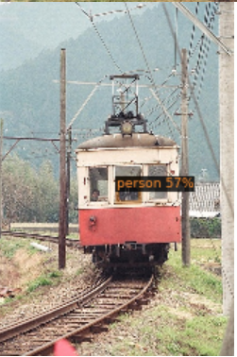 **In this, LR=0.0001, threshold=0.5, Retinanet identifies the person sitting inside the train**

**But fails to identify the train. This might be argued due to class imbalance in the training data.**

1. **Retinanet does much better when LR=0.00025, threshold=0.5 achieving AP50 score of 58.0239**
2. **Retinanet somehow does poorly on ‘cat’ and ‘dogs’ class.**
3. **Faster RCNN outperformed all the settings of Retinanet, achieving AP50 score of 67.1612.**
4. **One more observation was, Faster RCNN gives high confidence measure on each class predicted whereas Retinanet identifies objects with much lesser confidence.**